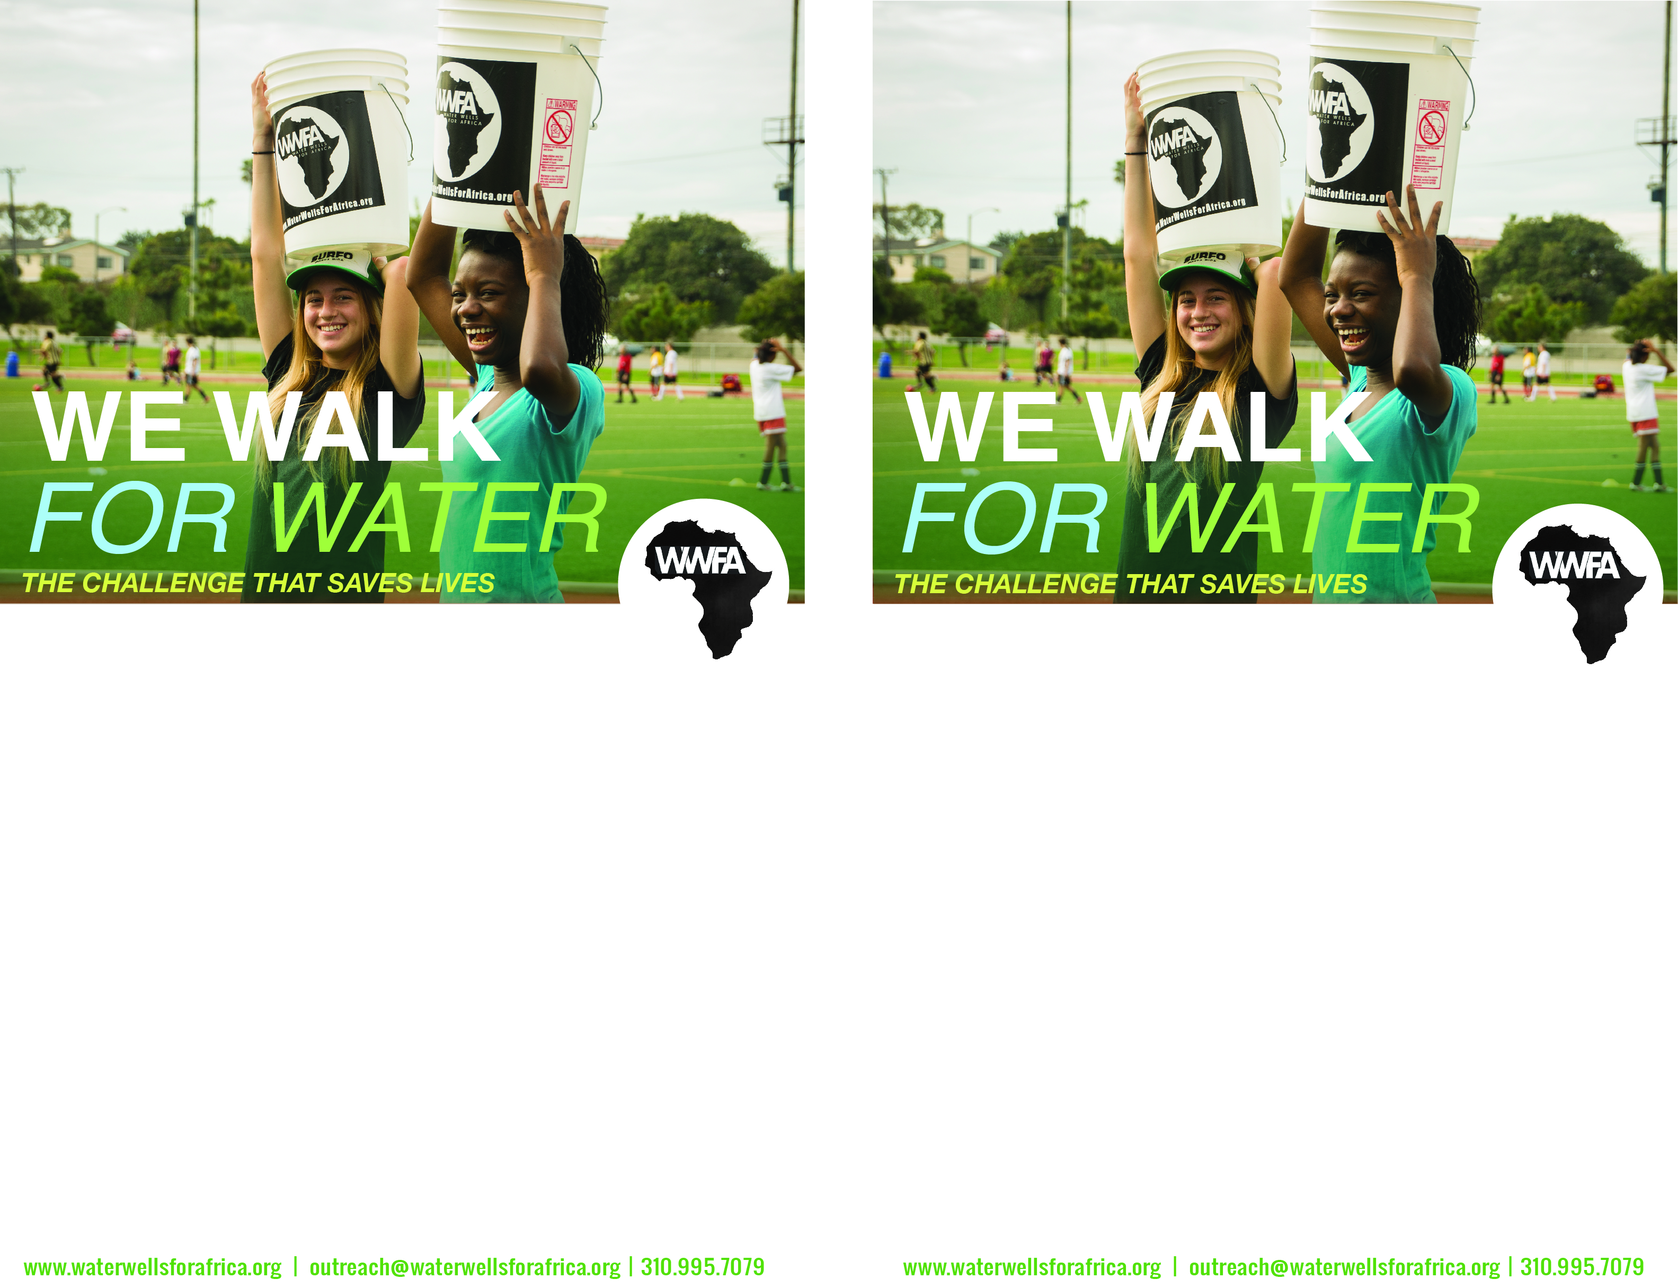

Please support my walk for clean water!

I will be taking the “WE WALK For Water” challenge on MM/DD/2020. The walk challenge is modeled after how rural African women and children have to collect water. We will be walking ___ miles with empty buckets to “collect” our water and then walking back ___ miles with water in our buckets.

I hope to raise awareness about Africa’s water crisis, but even more I am trying to raise $amount to make a true difference. For as little as $8, one person can have clean water for 20 years.

If you would like to PLEDGE to help me with my goal, let me know!

My contact is:

Thanks!

-*your name-*

Please support my walk for clean water!

I will be taking the “WE WALK For Water” challenge on MM/DD/2020. The walk challenge is modeled after how rural African women and children have to collect water. We will be walking ___ miles with empty buckets to “collect” our water and then walking back ___ miles with water in our buckets.

I hope to raise awareness about Africa’s water crisis, but even more I am trying to raise $amount to make a true difference. For as little as $8, one person can have clean water for 20 years.

If you would like to PLEDGE to help me with my goal, let me know!

My contact is:

Thanks!

-*your name-*